Lake Joondalup Environmental Impact Statement

Background:
As an attempt to improve access to Joondalup people have come up with a plan to build a bridge across lake Joondalup. The bridge will be connecting Wanneroo and Joondalup, the lake lies within the Yellagonga Catchment Area and is a coastal plain. The bridge will be constructed within 20 months and will spread out across 4 lanes. The bridge will be expected to be crossed 52,000 times per day there will be 6 large pillars buried in the mud in the lake to help create the bridge. There will supposedly be 200 floodlights to illuminate the bridge each giving off light of 100 meter range, there will also be gardens built on each side of the ramp to assist in helping the bridge blend into the local surroundings these gardens will be sprayed with fertiliser 4 times per year. The need for this bridge is to help decrease travel time to Joondalup or Wanneroo and to assist in traffic flow.

Variables:
Independent variable: The independent variable is the bridge that is being built over lake Joondalup.
Dependent variable: The dependent variable is the levels of (salinity, phosphates, nitrates etc) when the bridge is being built and once built and also the amount of macroinverterbrate and how they will be affected during the period of the bridge being built.
Controlled variable: The controlled variables would be the amount of light sources on the bridge, what time the lights will be on and the gardens will be sprayed with fertiliser 4 times per year.

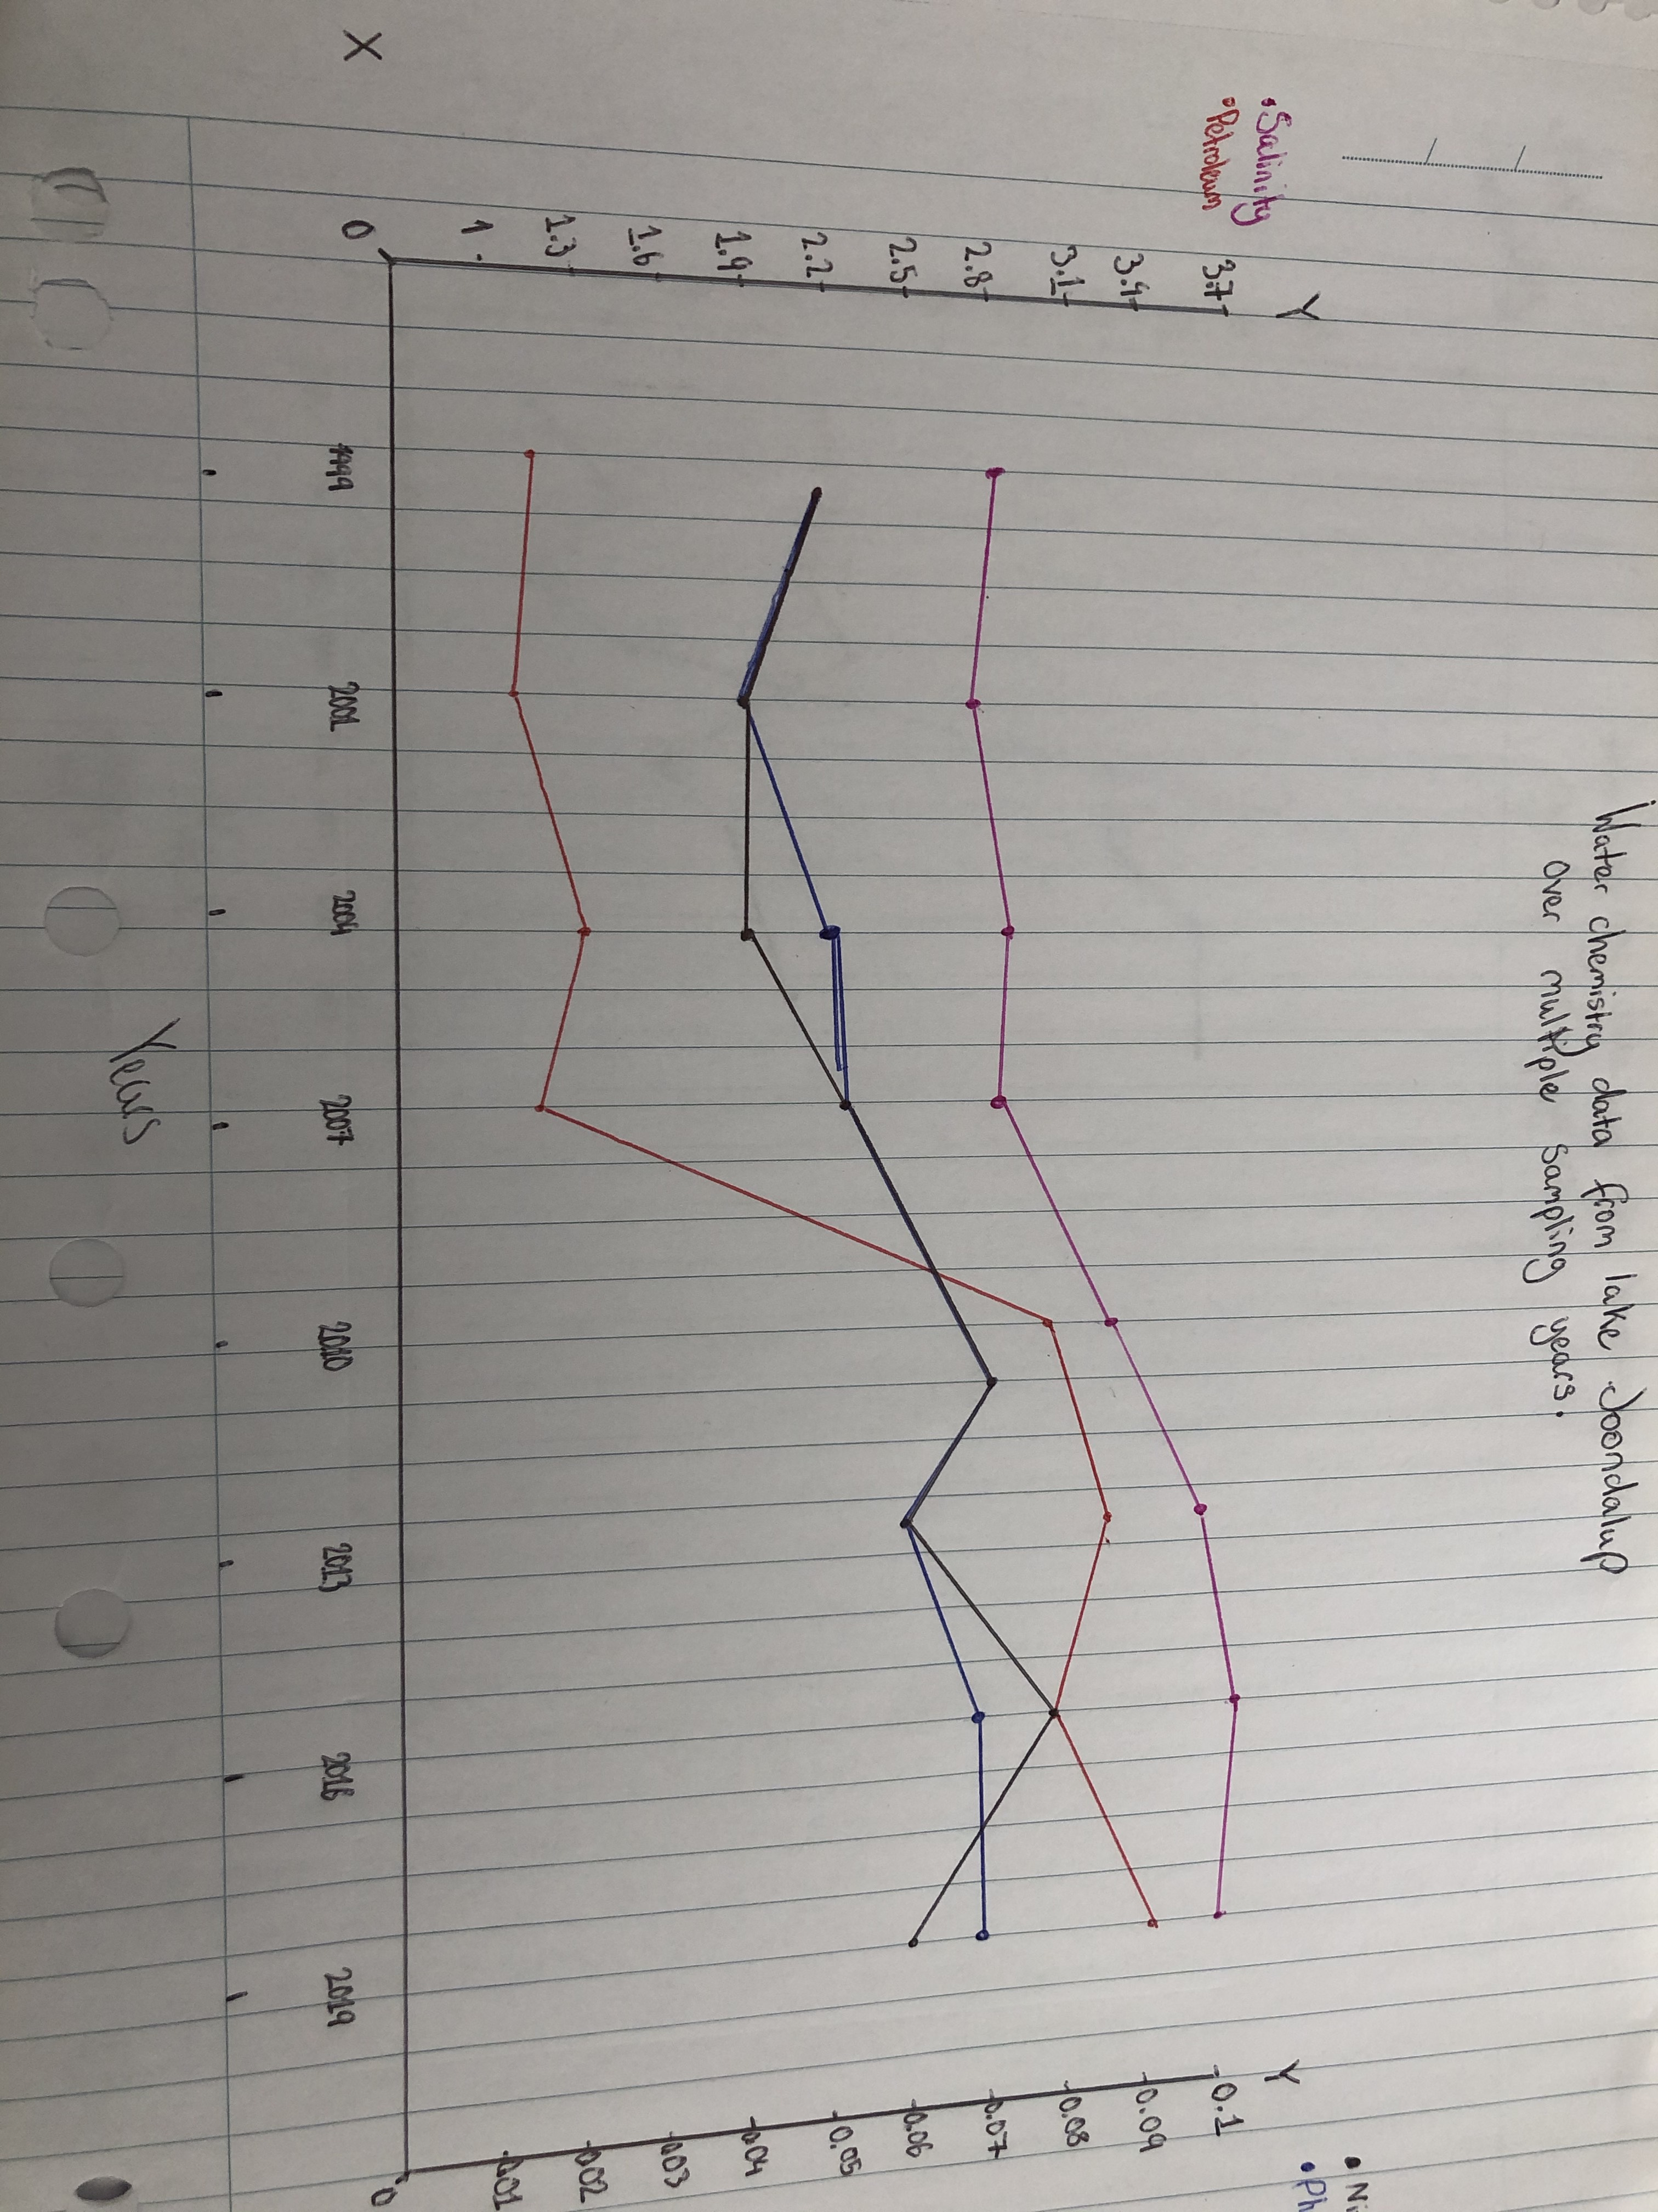

Results:
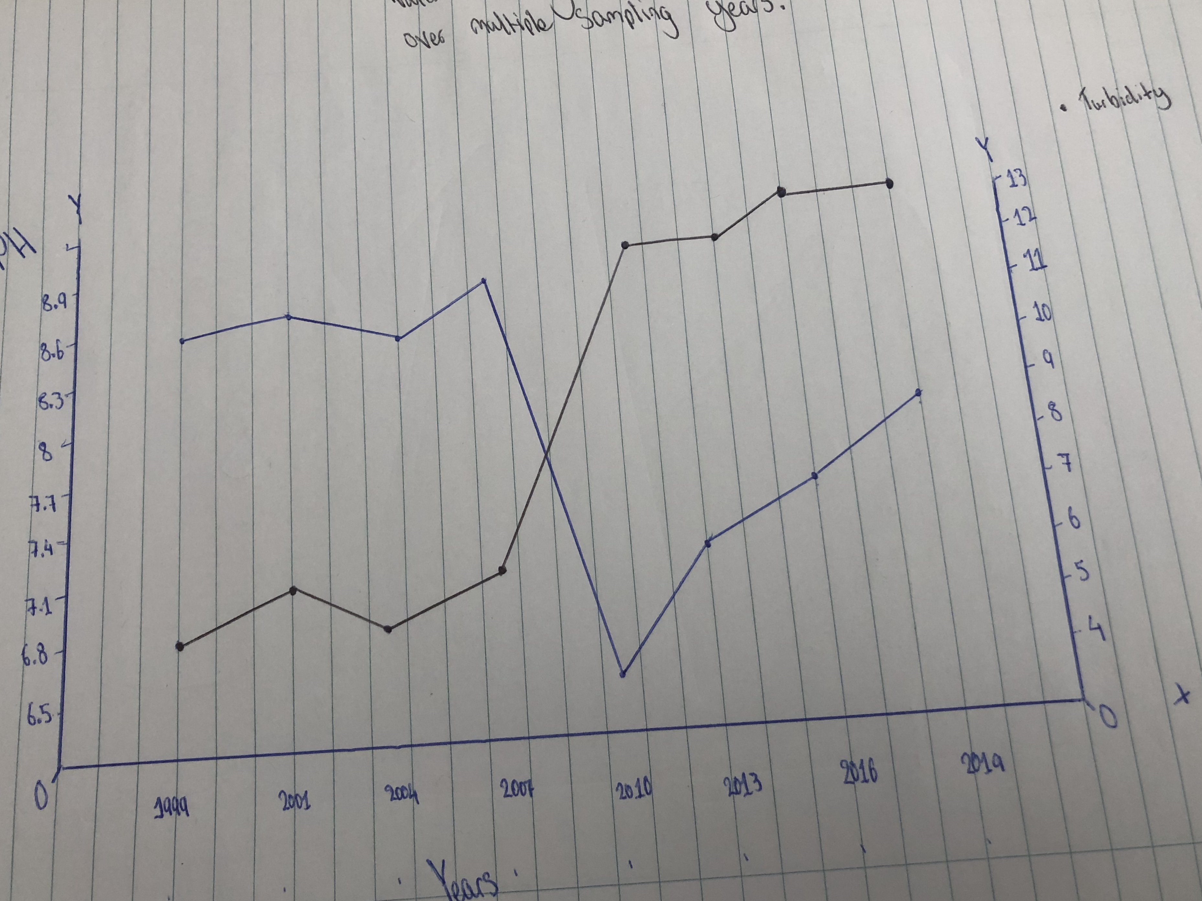
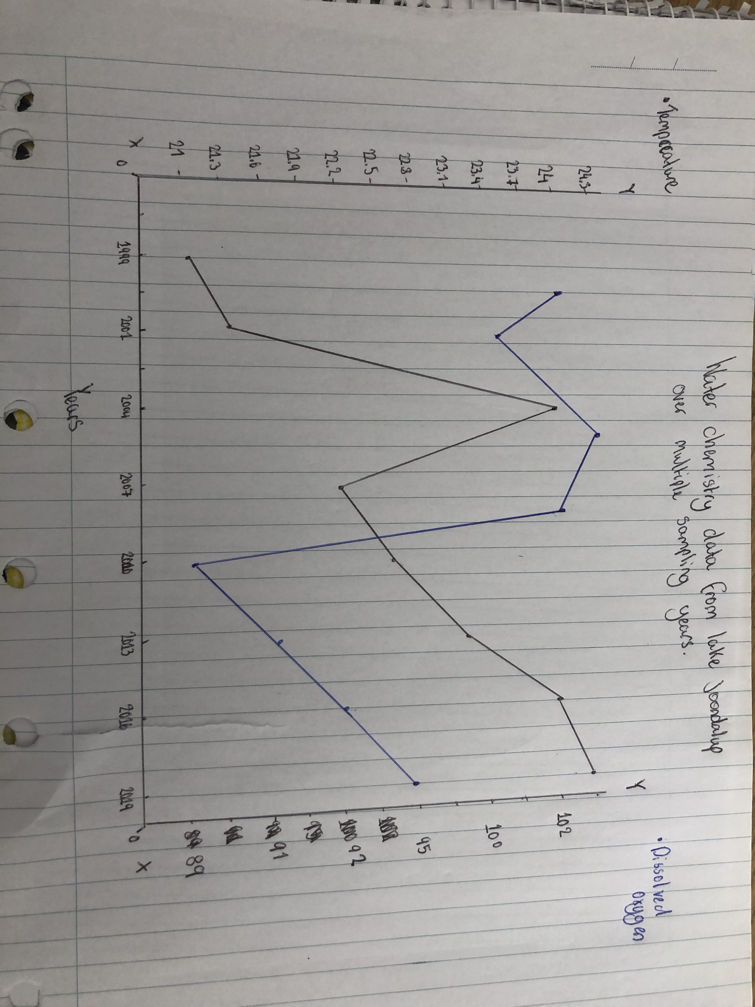
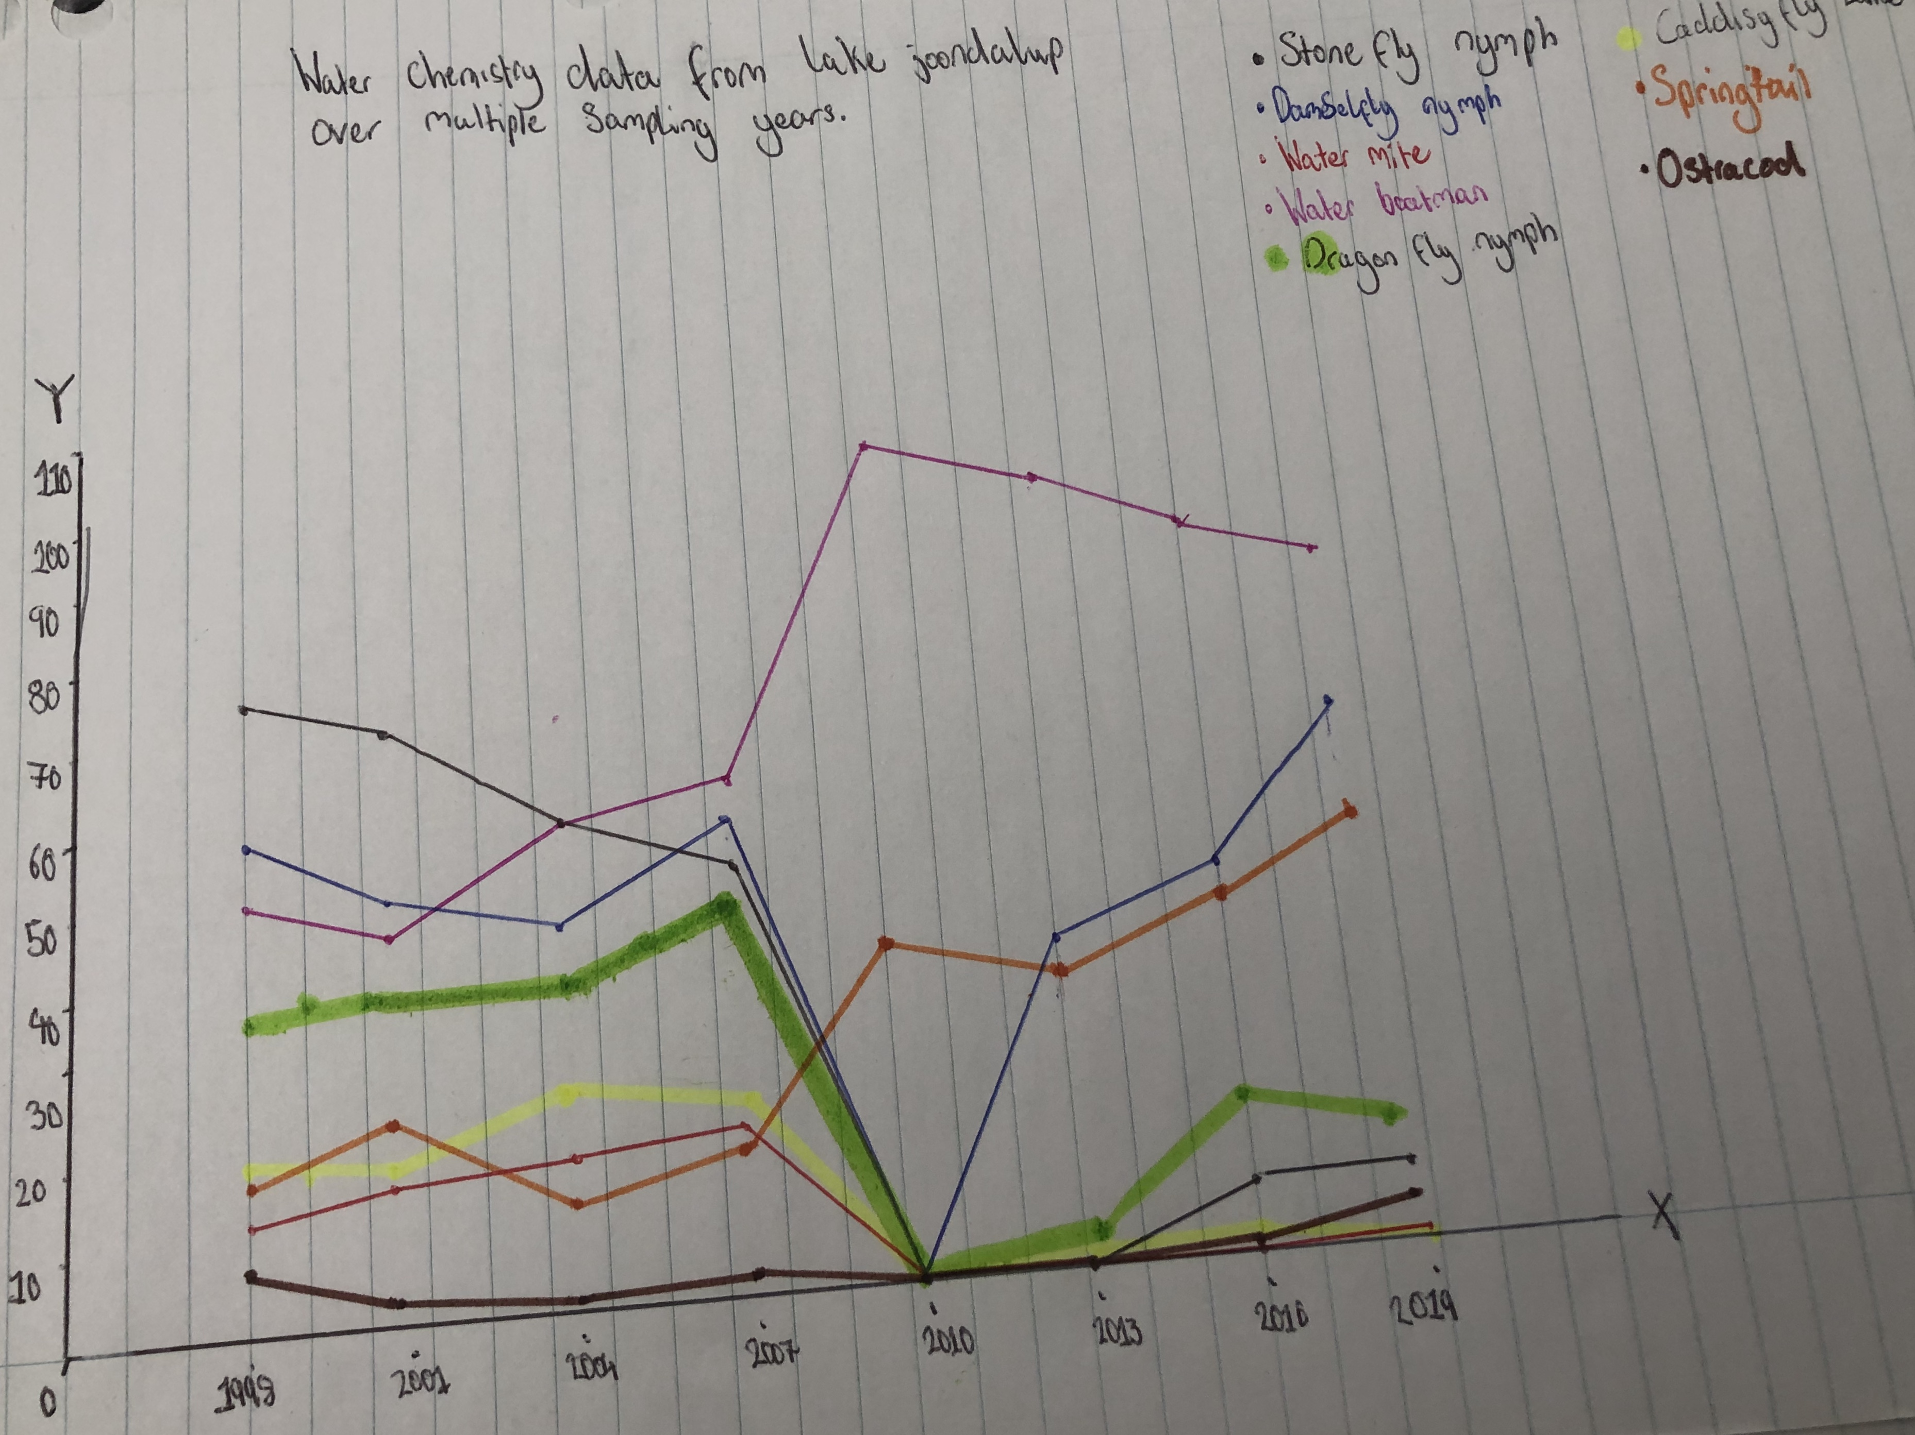

Results:
In the data their were two outliers Springtail and Water boatman these are both macroinverterbrates I believe they are outliers cause in 2010 all macroinverterbrates listed in the graph decreased down to zero except these two and I think the reason for that is because they don’t rely on PH and dissolved oxygen as much as all others.

Analysis:
In the data there is a visible trend of low species abundance in 2010 besides Springtail and water boatman everything else was at zero and if you look at the data about water chemistry in 2010 PH and Dissolved oxygen were both low in the same year this leads us to believe that most invertebrates rely on these things to survive. Over time most of the macroinverterbrates had a major decline but there are signs that there are slowly building up the numbers again and I believe its due to the PH and dissolved oxygen rising back up since 2010. I believe that petroleum could be the cause of macroinverterbrate numbers taking a massive hit cause as shown on the graph petroleum spiked in 2010 and this was also when the numbers took a toll for the species, also noise pollution and vibration could harm the macroinverterbrates. My theory with the bridge being built we will see another massive decrease in the macroinverterbrates due to them having to use tools and machines that use petrol so we could see a repeat of what happened in 2010. This proposed bridge could also hurt the habitats of birds due to the builders having to clear land where the bridge will go most of the land is trees around that area, there are 7 listed aboriginal sites with the park the making of this bridge would impact upon them the most because its apart of their history it was an important camping area for watering, food gathering, camping and tool making.A positive effect about the bridge it will help flow traffic to Joondalup or waneroo better but a negative it will affect macroinverterbrates, birds and indigenous people due to it either being a cultural spot or a habitat either way it’ll be getting chopped down.

Reliability and validity:
I believe that the report is fairly reliable due to the time frame in the data being spread out over ten years can really show you what has happened since 1998 around the lake. I also believe the validity of the report is factually correct just by looking at the data that was given out.

Mitigation:
The builders could put in place a fence around the perimeter of the lake and where the bridge is being built to help keep people away from disturbing the wildlife. A recommendation to the builders could be the ground disturbed can’t have a high level of noise pollution and petroleum tools used and some remediation should take place to restore area that has been disturbed and put back as best as possible.

Evaluation:
Two limitations with the experiment that could affect the data could possibly be not having enough information like need a bigger time period to see the chemistry of the water over a longer period of time, or more information about lake Joondalup for a better understanding. We could improve on this by instead of testing each 3 years test every six months to one year for more accurate results.

Conclusion:
My findings from the investigation is that when ocean reef road was constructed petroleum was released into the air by vehicles used to build the road which would then transfer into the lake this caused a lot of macroinverterbrates to depreciate in numbers. I personally think this would be a horrible idea due to the pollution it will cause to the lake to the destruction it’ll cause to migratory birds habitats and the culture it’ll destroy for the indigenous people because this was a important camping area for them. It will just be a bigger mess then 2009-2010 was when ocean reef road was.

